Zachary Kolodny

112311827

CMSC424 – MMDA Final Project

Scope of Project

The first task is to analyze the files that can be placed into the MMDA and figure out a database schema based on the common attributes of file metadata (date created, whether the file is local or referenced via a URL, a path to the file (URL or local), the size of the file, type of file i.e. extension, and externally linked files (if the file is HTML, for example)).

The next task is to give the user a way of adding the input files into the database. The user needs to be able to select a file or input a file path and have that file placed into the database. The file must be one of a number of pre-specified formats. If the file is HTML, the user may opt to add the files that the HTML file links to. At this stage, the MMDA needs to figure out whether the links in the HTML file are valid, i.e. whether they are broken or if they still link to a file. Only valid links should be added into the MMDA. Additionally, if a directory is selected, the user can decide which contents of the directory should be placed into the database. During each insertion of a file or directory, a GUID should be generated to identify each file and create a look-up table that maps GUIDs to DAGRs.

Finally, we need a way for the user to query the database based on the values of the metadata attributes stored. For example, the user may want to return all the files that were created past a certain date that have a common extension, e.g. .pdf.

Assumptions

1. The user is running a Unix-based machine. This means the local file system will be Unix-like, and paths to files will appear as /path/to/file rather than in the Windows format (C:\path\to\file).
2. The user must be able to access the internet to input HTML files and to follow links from HTML files, even if stored locally. Internet access also allows the user to enter queries to processed by our web server.
3. The user’s inputs are not unreasonably large. The database will have limited storage capacity and the user cannot input so many files that the database will be unable to store all DAGRs to the files.

Technical Problems

**Problem**: Deciding how to follow links from HTML files.

**Solution**: When we parse an HTML file to find the files that are linked, we need to decide how many levels deep to follow links. If the user inputs an HTML file, it may contain links to other HTML files. If the user specifies a recursion depth of 1, for example, then the MMDA would only add the files directly linked to by the HTML file. However, for a recursion depth of 2, the MMDA would not only add the files directly linked by the original HTML file but also files linked to by any HTML file that were linked to by the original HTML file. This generalizes to higher levels of recursion. Our solution is to allow the user to specify the recursion depth. Our solution is to set the recursion depth to 1 by default and allow the user to specify higher levels of recursion if desired.

**Problem:** Generating GUIDs for files

**Solution:** We will use the code specified by the project description to generate GUIDs for each file on the server-side. This will be down automatically when the program decides to add a DAGR to the database. However, we need to decide how to compute the GUIDs, i.e., whether it should be based on file content or file metadata.

**Problem:** Choosing database software to use: SQLite vs. PostgreSQL

**Solution:** We are choosing to use SQLite because of the easier learning curve. After a comparison between the two, we realized that PostgreSQL is far more advanced.

**Problem:** Integrating our database with the back-end

**Solution:** Since we are using Flask for the back-end, we decided to use SQLAlchemy, a Python toolkit designed to convert relations into objects. This makes it much easier to query the database from our server.

**Problem:** Handling duplicate entries

**Solution:** Since each entry is mapped to a unique GUID, all we have to do to prevent the insertion of duplicates is compute the GUID of an entry before inserting it and performing a look-up in a hash set of GUIDs to determine if the file is already present. We only insert the file if the GUID is not present in the hash set.



|  |  |
| --- | --- |
| TASK NAME: | Insert File Task |
| PERFOMER: | Python + SQLite |
| PURPOSE: | Insert file metadata into the MMDA database |
| ENABLING CONDITION: | File is one of the accepted file types and has not already been inserted into the database. In addition, if the file is linked via a URL, the link is valid i.e. not broken. User must input the file path or URL. |
| DESCRIPTION: | Inserts the designated file into the MMDA database. |
| FREQUENCY: | Whenever specified by the user. |
| DURATION: | Time needed to check if the file is already present plus the time needed to insert metadata into the database. |
| IMPORTANCE: | Critical |
| INPUT: | File name or URL. |
| OUTPUT: | Whether the insertion succeeded. |
| SUBTASKS: | GUID generation |
| ERROR CONDITION: | None |

|  |  |
| --- | --- |
| TASK NAME: | Bulk Add Task |
| PERFOMER: | Python + SQLite |
| PURPOSE: | Insert multiple file metadata into the MMDA database |
| ENABLING CONDITION: | Files are one of the accepted file types and have not already been inserted into the database. In addition, if the files are linked via a URL, the links is valid i.e. not broken. User must input the file paths or URLs. |
| DESCRIPTION: | Inserts the designated files into the MMDA database one-by-one. |
| FREQUENCY: | Whenever specified by the user. |
| DURATION: | Time needed to check if each file is already present plus the time needed to insert each file’s metadata into the database. |
| IMPORTANCE: | Critical |
| INPUT: | List of file names and/or URLs. |
| OUTPUT: | List of booleans specifying whether each input succeeded. |
| SUBTASKS: | GUID generation |
| ERROR CONDITION: | None |

|  |  |
| --- | --- |
| TASK NAME: | Orphan and Sterile Report |
| PERFOMER: | Python + SQLite |
| PURPOSE: | Find which files have no DAGR descendants and which files have no parents. |
| ENABLING CONDITION: | User request |
| DESCRIPTION: | Database query is made that looks for entries in the relation that do not have references to other files or have no references to themselves. |
| FREQUENCY: | Whenever specified by the user. |
| DURATION: | Time needed to perform query. |
| IMPORTANCE: | Critical |
| INPUT: | None |
| OUTPUT: | List of orphan and sterile files. |
| SUBTASKS: | SQL queries |
| ERROR CONDITION: | None |

|  |  |
| --- | --- |
| TASK NAME: | DAGR Deletion |
| PERFOMER: | Python + SQLite |
| PURPOSE: | Delete a file from the MMDA database |
| ENABLING CONDITION: | File exists within the database and user specifies the GUID to delete. |
| DESCRIPTION: | Performs an SQL delete query on the file. |
| FREQUENCY: | Whenever specified by the user. |
| DURATION: | Time needed to perform query. |
| IMPORTANCE: | Critical |
| INPUT: | File name, URL, or GUID |
| OUTPUT: | Whether the deletion succeeded. |
| SUBTASKS: | GUID generation |
| ERROR CONDITION: | None |

PHASE 2:

Purpose

The purpose for this part of the project is to model out an optimal schema for the database through an ER Model and its Boyce-Codd form. This helps reduce the amount of unnecessary information in each table as well as highlighting the right fields to use as primary and foreign keys. The pseudocode for each task helps to demonstrate this concept as well as show a standardized way to query certain information.

Relational Schema

../../../../Downloads/er.pdf

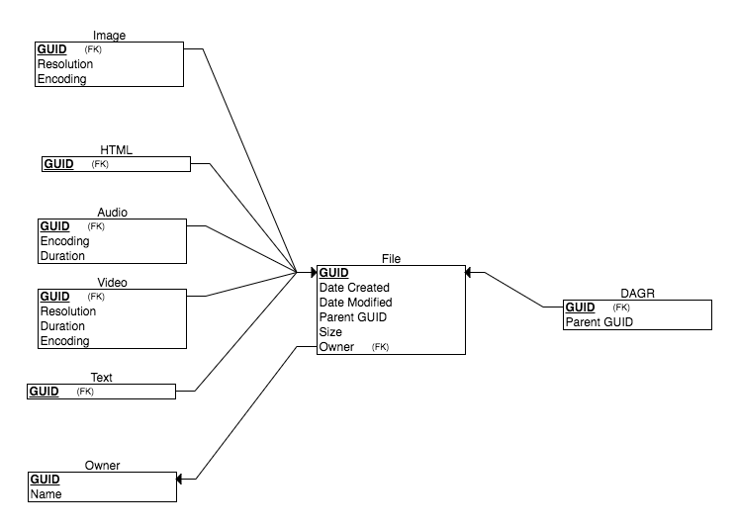

Task Pseudocode and DML

TASK: INSERT FILE

If query for file based on file path returns nothing:

Generate GUID

INSERT into FILE (List of Values)

INSERT into OWNER(Name, FileGUID)

Determine file type and insert into correct table

Return True

Else:

Return False

TASK: BULK ADD

Walk through FileSystem Tree:

Call Insert File on each File

TASK: ORPHAN AND STERILE REPORT

INNER JOIN DAGR and FILE on GUID and then do a MINUS on that and FILE

TASK: DAGR DELETION

Generate array of all files with DAGR as an ancestor

For file in array:

DELETE FROM FILE where GUID=FileGUID

DELETE FROM OWNER where GUID=FileGUID

DELETE FROM DAGR where GUID=FileGUID

Determine file type and delete from the corresponding table

Database and Web Server

I was able to get my SQLite database up and running and successfully attached it to my Flask web server.

PHASE 3:

**Purpose:**

This phase of the project is bringing everything together. Pulling together all of the theoretical ground work completed in phases 1 and 2, I finally implemented the MMDA (Multi-Media Data Aggregator) which includes a database, web server, and web interface. This was accomplished by using SQLite3 for the relational database (with the help of SQLAlchemy), Flask was the backbone of the webserver allowing the interface to successfully interact with the database, and HTML/CSS for the web interface.

**Problems:**

The main problem in this part of the project was the bulk upload task which was to be done from a filesystem/CD/etc. The two components of this problem were having the user input the directory that the bulk upload would start in. In the end, I decided to use a simple text input rather than a file input form. This allowed me to get the precise location instead of just the file name and concentrate on more important aspects such as reports. The other issue was figuring out the complexities of the python method os.walk. This problem was solved through careful testing and “tinkering” in order to understand how it worked.

**Phase 2 Revisions:**

ER Diagram

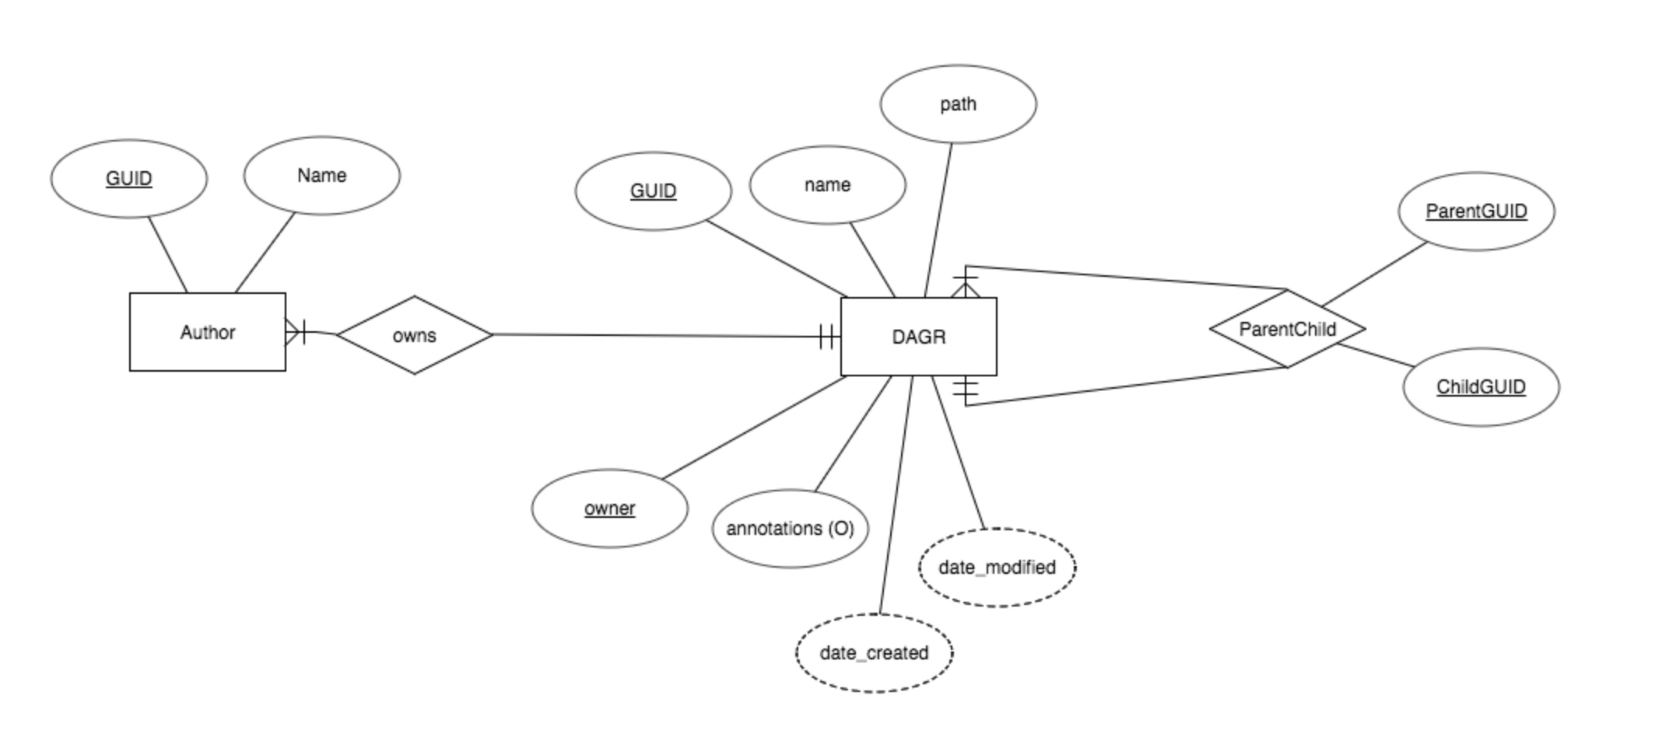

Relational Schema

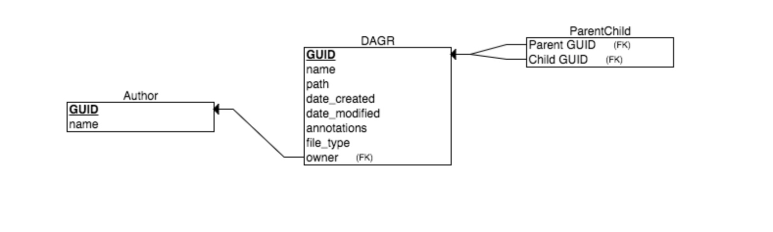

**Phase 3 Documentation:**

Manual

Welcome to my implementation of a Multi-Media Data Aggregator. This allows you to store metadata on various files, their relationships to one another, and from different sources both online and from your file system. The Homepage talks about the purpose of this application as well as a brief overview.

The website is laid out in two main components:

1. MMDA Modification
2. MMDA Reports

In the first part, which starts at the homepage, you are able to create DAGRs (folders and subfolders) specifying who where you’d like it to be created (as a subfolder or a new folder), upload webpages to a specific DAGR (along with all reference links/images), bulk upload files from your filesystem/removable device (through manual input of path), and delete DAGRs from the MMDA. All these options are available through the side bar conveniently on every page. The last option on the side bar, Reports, brings you to the second component. The Homepage can be reached at any time through the ‘Home’ button in the top left of the screen.

As already stated the second component, reached from the side bar of any page from the first part, is the Reports feature. Once ‘Reports’ is selected, the sidebar transforms and provides a whole new range of options, adding a ‘Reports’ link under ‘Home’ allowing users to navigate back to the Reports Homepage whenever they’d like. On the Reports Homepage, you will find a very brief description of each of the types of Reports you can generate. These are:

**1 - DAGR Metadata Query**

Typically, we would like to write queries to find DAGRs using the metadata attributes, such as date, author, type, size, or keywords in the annotations.

**2 - Orphan and Sterile Report**

Generate all the DAGRs that are not referenced by a parent DAGR or have no descendant DAGRs.

**3 - Reach Queries**

Very often we would like to find all the DAGRs that can be reached by a given DAGR (descendants) or those that point to it (ancestors).

**4 - Time-Range DAGR Report**

Generate a report with several preselected data items for all the DAGRs created or entered in a given time range.

Within each report you will notice there is also a ‘View’ button next to each and every DAGR. This brings up a more detailed page about the DAGR with information such as GUID, Name, path, Type, Parent, Date Created, Date Modified, a list of Ancestors, and a list of Descendants (each of which containing a link to its inspection).

Testing

Testing was done by bulk uploading random directories from my filesystem to the MMDA and manually checking for correctness against the actual filesystem structure. One test case which is unusual yet manageable was the addition of a DAGR who’s siblings are all DAGRs and children are all DAGRs. This is a difficult scenario because while traversing files the os.walk function dives down into the directory until it hits a file. Another, more occurring, test case is the addition of a (local) DAGR that is already present in the MMDA. Handling this case is done by querying for DAGRs of the same name and comparing paths since these attributes combined must be unique, a webpage may be inserted into 2 different DAGRs but in an effort to save space, using the name and path we can obtain the GUID and just insert an entry into the ParentChild table.

Limitations and Improvements

The limits of the system come from the bulk upload and HTML parsing. The HTML parsing only grabs the immediately referenced links and images. A long-term goal would be to crawl each of those webpages continually adding to the database or to incorporate a task that crawls/parses the next set of links/images on command. Bulk uploading is another area that is limited. As of now you have to manually input the path to the data which can be annoying and tedious, even when it is not there are still edge cases that must be handled dealing with the string encoding of the names/paths which can throw errors.

The majority of improvement can be done at the interface level, but deletion and relation schema have room for growth as well. In terms of relation schema, having several tables each for a different file type would be nice but this requires a master list of which file extensions belong to a certain file type to keep it at a high level of abstraction. Deletion as of now is only done by shallow delete (removing the DAGR from the DAGR table and updating ParentChild to remove all occurrences where it is either a Child or a Parent).

This is my first experience with full on web development so a majority of improvement can be done in the interface. It can be made more universally accessible with different devices through adoption of Bootstrap or CSS Grids. Another idea was to make it with react as there is only a portion of the screen that needs to be updated every time but these were beyond my abilities given time constraints/overall work load. Going forward I would incorporate a login window into the Homepage to keep track of the user currently editing the MMDA and stop them from editing DAGRs that they do not own. However, for the scope of this project I would like to make this service collaborative so people can share the MMDA. Lastly, my goal is to make it so that users can update annotations from the DAGR Inspection view, this will be implemented if I have time.